

**NET320-Database Systems**

**SWS213-Database Design**

**Spring ‘18**

**Class AssignmentV2- Courier Company Tracking -RELATIONSHP DIAGRAM, DB**

CLO2 Design and implement a database solution based on a given business scenario

|  |  |  |  |  |
| --- | --- | --- | --- | --- |
| **Task 1/5** | **Task 2/5** | **Task 3/5** | **Task 4/10** | **Total/20** |
|  |  |  |  |  |

**Name:**

**ID:**

**General Guidelines**

* Class Assignment is due on 17 of April 2018 by 6:00 PM.
* Assignment counts 5% of your lab grades.
* Should upload the word file along with the MySQL to moodle.
* Should rename the files with your first name followed by student’s id number.

**Software** **Required**

* MySQL SERVER
* WORKBENCH

Create a database for the Courier Company ABC.

Courier Company ABC prides itself on having up-to-date information on the processing and current location of each shipped item. Courier Company ABC relies on a company-wide information system.

Shipped items are the heart of the Courier Company ABC product tracking information system.

Shipped items can be characterized by item number weight, (unique), dimensions, insurance amount, destination, and final delivery date.

Shipped items are received into the Courier Company ABC system at a single retail center. Retail centers are characterized by their type, uniqueID, and address.

Shipped items make their way to their destination via one or more standard UPS transportation events (i.e., flights, truck deliveries).

These transportation events are characterized by a unique scheduleNumber, a type (e.g, flight, truck), and a deliveryRoute. Create an Entity Relationship diagram that captures this information about the Courier Company ABC system. Also, indicate identifiers and cardinality constraints.

**Task 1- Draw the ER Diagram and paste your diagram below.**

**Task 2- Create a database**

**Task 3- Populate the tables (Students can use random information)**

**Task 1:**

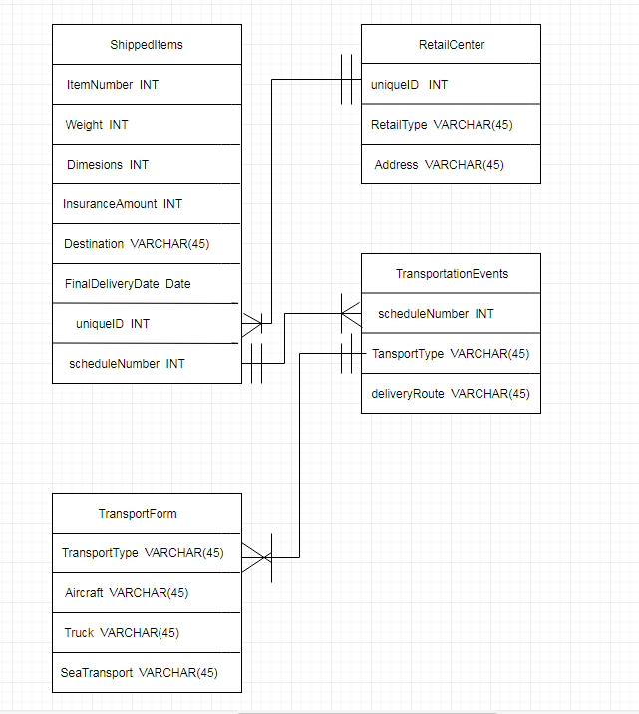

**SQL:**

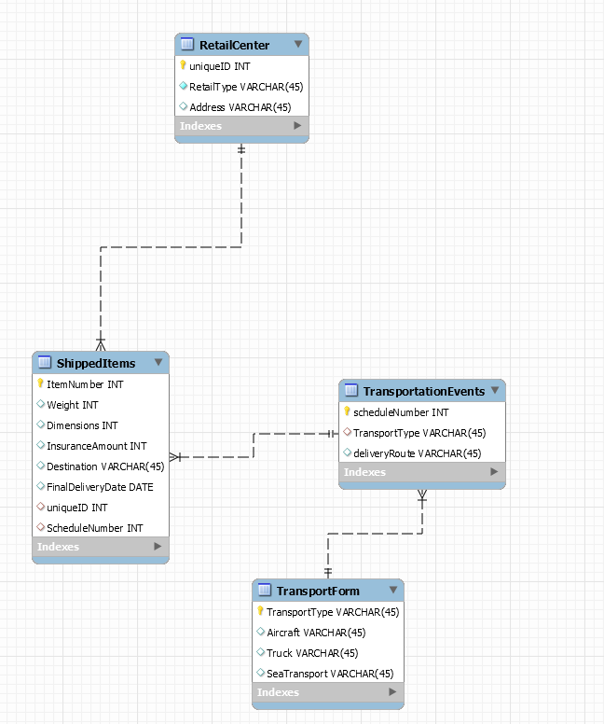

**Task 4- Answer the queries (Screenshot the output, write down the queries)**

1. List all the shipments that use the mode of transport as flight.

SELECT *

FROM mydb.shippeditems, mydb.retailcenter, mydb.transportationevents, mydb.transportform

WHERE shippeditems.uniqueID = retailcenter.uniqueID AND

shippeditems.ScheduleNumber = transportationevents.scheduleNumber

AND transportationevents.TransportType = transportform.TransportType AND Aircraft = 'Flight' ;

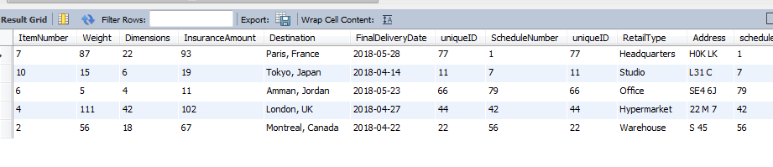

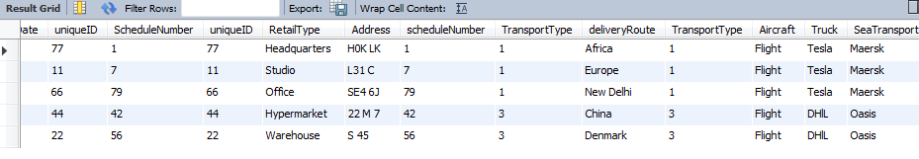

1. List all the shipments that use the mode of transport as flight and insurance value is less than 100 USD.

SELECT *

FROM mydb.shippeditems, mydb.retailcenter, mydb.transportationevents, mydb.transportform

WHERE shippeditems.uniqueID = retailcenter.uniqueID AND

shippeditems.ScheduleNumber = transportationevents.scheduleNumber

AND transportationevents.TransportType = transportform.TransportType AND Aircraft = 'Flight' AND InsuranceAmount < 100;

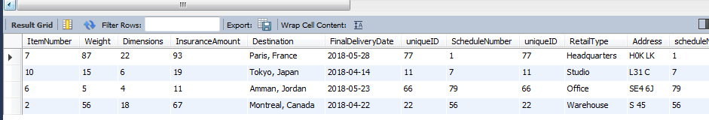

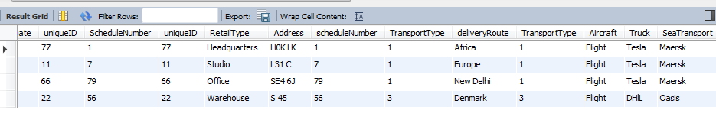

1. List shipments id that use the mode of transport as Tesla and their address.

SELECT ItemNumber, Address

FROM mydb.shippeditems, mydb.transportationevents, mydb.transportform, mydb.retailcenter

WHERE

shippeditems.ScheduleNumber = transportationevents.scheduleNumber AND shippeditems.uniqueID = retailcenter.uniqueID

AND transportationevents.TransportType = transportform.TransportType AND Truck = 'Tesla';

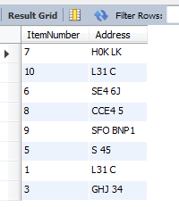

1. Sort the shipments based on the weight and also list the destination along with the transportation route.

**SELECT ItemNumber, Weight, Destination, deliveryRoute**

**FROM mydb.shippeditems, mydb.transportationevents, mydb.transportform, mydb.retailcenter**

**WHERE**

**shippeditems.ScheduleNumber = transportationevents.scheduleNumber AND shippeditems.uniqueID = retailcenter.uniqueID**

**AND transportationevents.TransportType = transportform.TransportType**

**ORDER BY Weight;**

